Analysis report
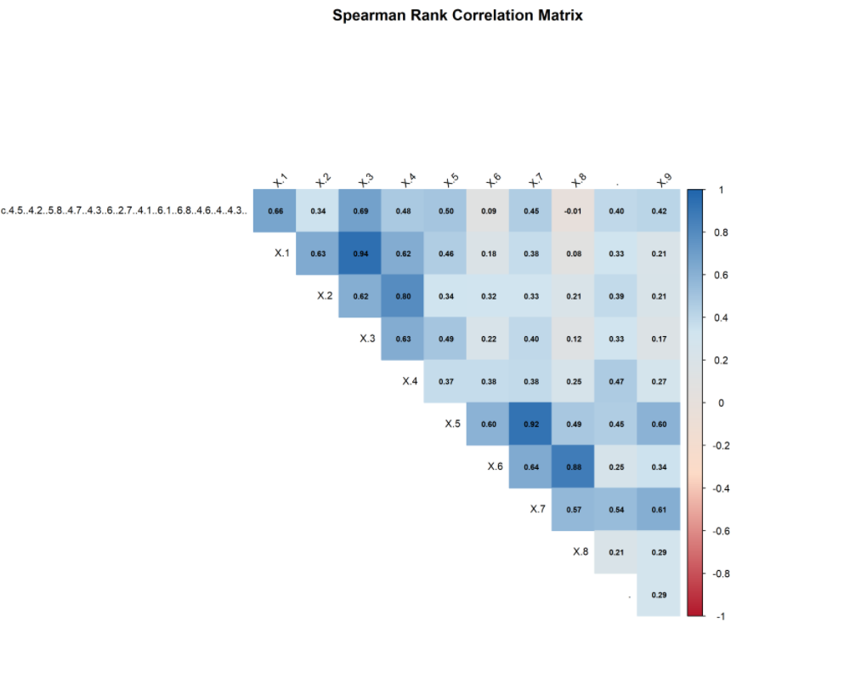Figure 1: Spearman correlation matrix heatmap (red = positive, blue = negative correlations)
The correlation analysis reveals the strength and direction of relationships between morphometric traits. Positive correlations indicate traits that increase together, while negative correlations suggest trade-offs. The presence of significant correlations justifies dimensionality reduction through PCA.

PCA VISUALIZATION
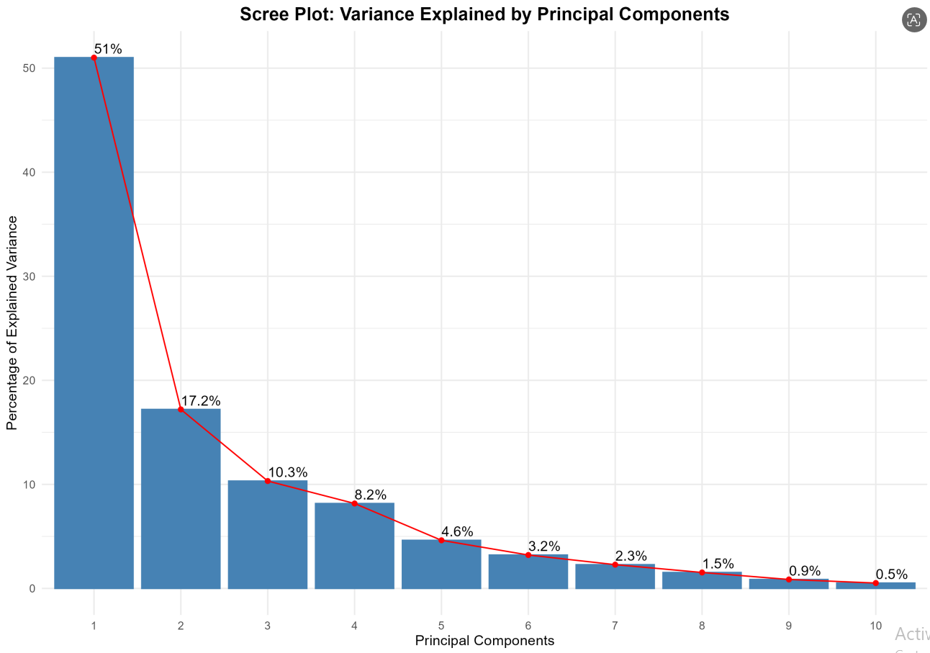Figure 2: Scree plot showing variance explained by each principal component
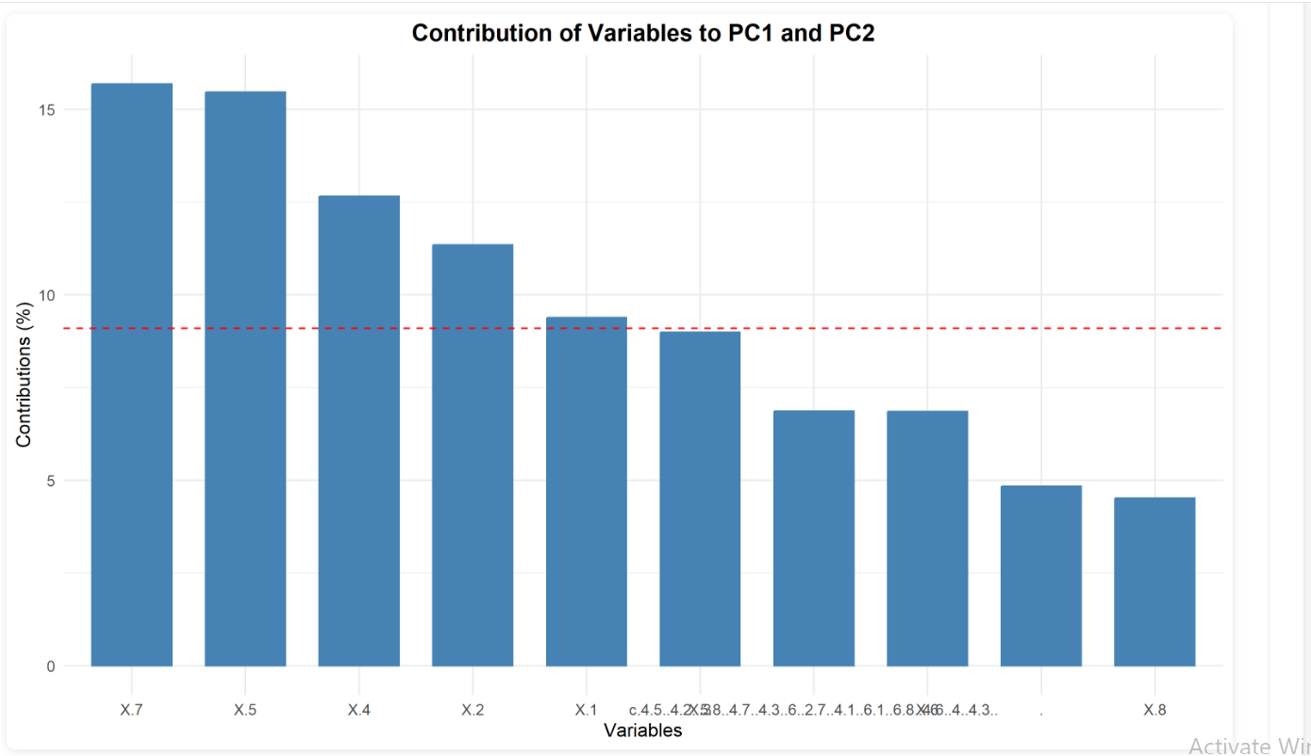
Figure 3: Contribution of each original variable to PC1 and PC2

The PCA revealed that the first three principal components explain 78.5% of total variance:
- PC1 explains 51% of variance
- PC2 explains 17.2% of variance
- PC3 explains 10.3% of variance

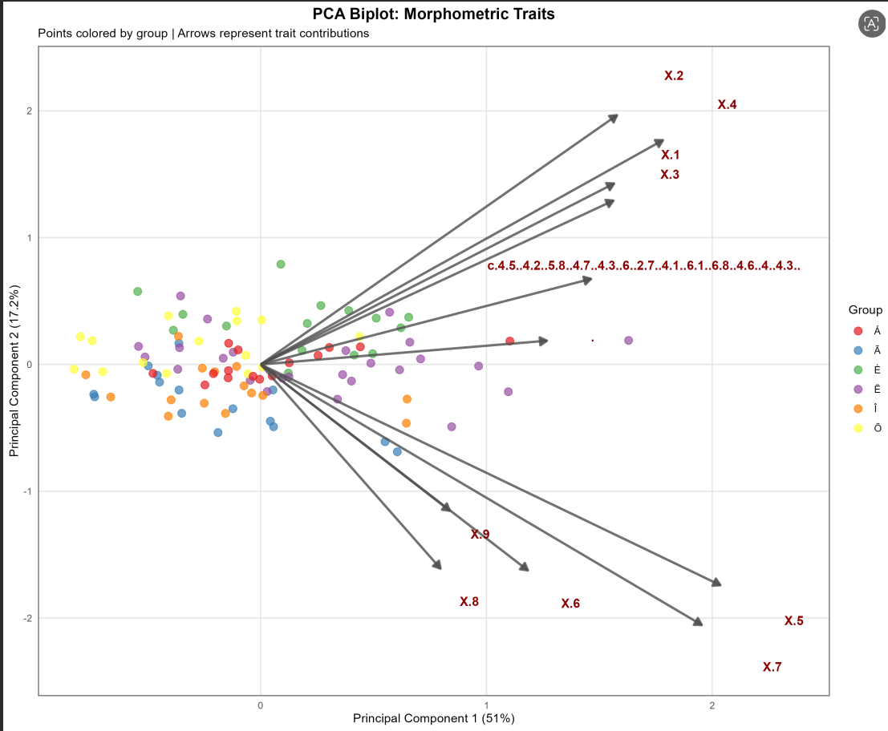
Figure 4: PCA biplot with points colored by group (without confidence ellipses)

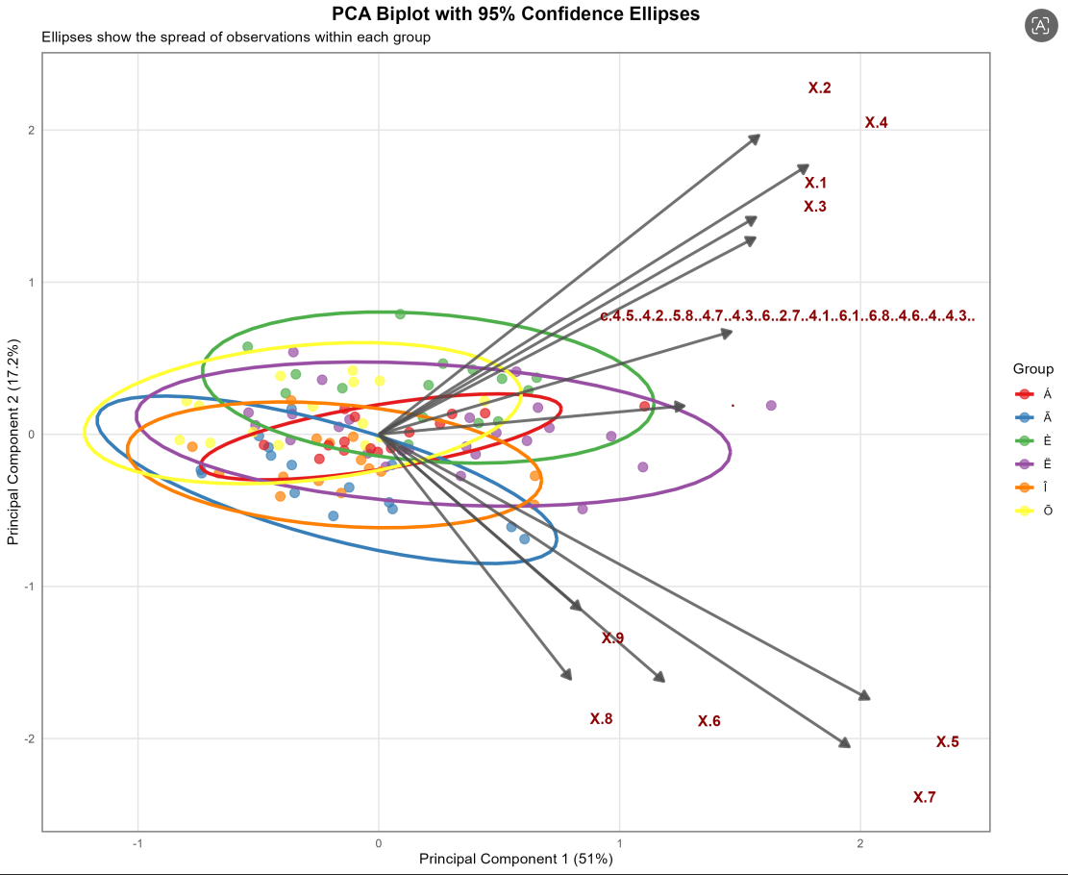Figure 5: PCA biplot with 95% confidence ellipses for each group
Here we can see that the PCA biplots with 95% confidence ellipses show the degree of separation between groups:
- Á vs Ã: Overlapping (distance = 0.39 units)
- Á vs È: Overlapping (distance = 0.33 units)
- Á vs Ë: Overlapping (distance = 0.21 units)
- Á vs Î: Overlapping (distance = 0.29 units)
- Á vs Õ: Overlapping (distance = 0.38 units)
- Ã vs È: Overlapping (distance = 0.72 units)
- Ã vs Ë: Overlapping (distance = 0.56 units)
- Ã vs Î: Overlapping (distance = 0.11 units)
- Ã vs Õ: Overlapping (distance = 0.45 units)
- È vs Ë: Overlapping (distance = 0.31 units)
- È vs Î: Overlapping (distance = 0.61 units)
- È vs Õ: Overlapping (distance = 0.51 units)
- Ë vs Î: Overlapping (distance = 0.48 units)
- Ë vs Õ: Overlapping (distance = 0.58 units)
- Î vs Õ: Overlapping (distance = 0.37 units)
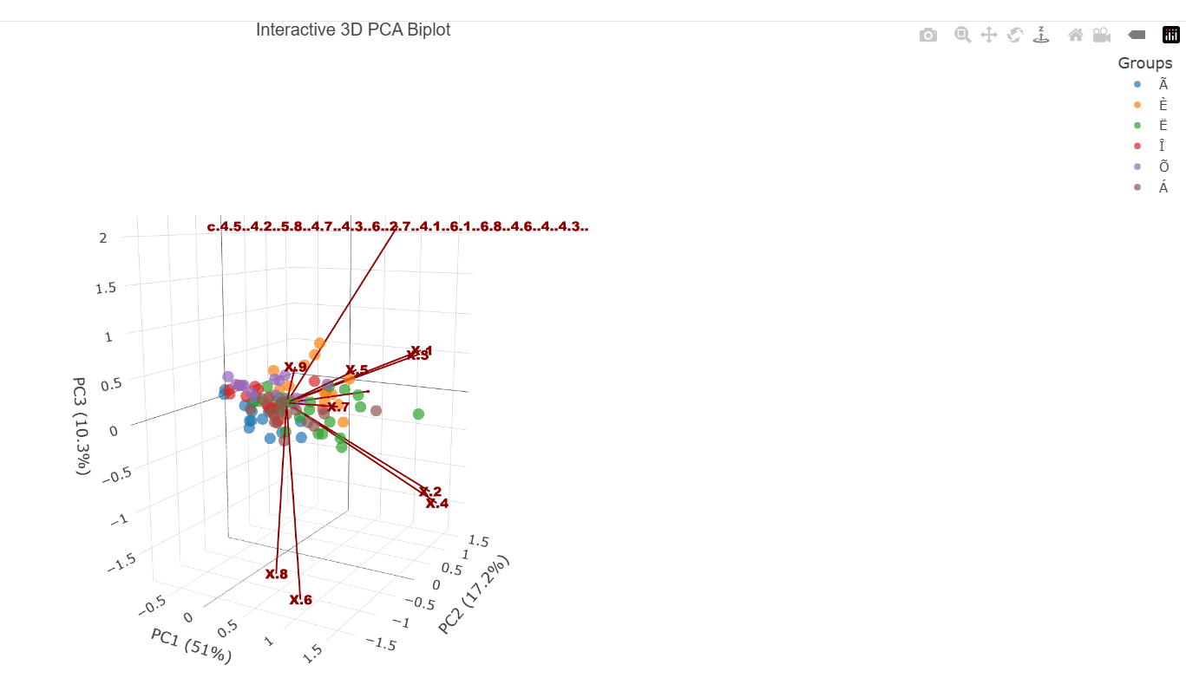
Figure 5: Xploring the PCA results in three dimensions with interactive controls
Here this 3D PCA biplot visualizes shape variation across the dataset, with PC1 explaining 51%, PC2 17.2%, and PC3 10.3% of total variation—together capturing nearly 80% of the total morphological difference. Individual samples cluster closely at the center while distinct variable vectors (x1–x9) show how each trait drives separation: x2 and x4 strongly define the PC1/PC2 axis, while x6, x7, and x8 pull variation in the opposite direction, and x9 contributes primarily along PC3. This confirms these features are the main drivers of morphological differentiation in the analysis.

